DECONTAMINATION AT NUCLEAR POWER PLANTS

INTRODUCTION
In order to reduce the radiation fields around nuclear power plants, and, consequently, to limit the radiation exposure of and dose commitments to the operating and maintenance personnel, the contamination build-up should be kept to a minimum.
The most fruitful approach, from the point of view of economics and efficiency, is to tackle the problems of contamination and decontamination in the design and construction phases of the reactor. To do this, knowledge gained from the operation of existing power reactors should be used to make improvements in new designs. New structural materials with low corrosion rates or whose constituents are not activated by neutrons should also be used.
For older reactors, in most cases it is already too late to incorporate design changes without extensive and expensive modifications. For these plants, decontamination remains the most efficient way to reduce radiation fields.

RADIOACTIVE CONTAMINATION IN NUCLEAR POWER PLANTS
Every type of nuclear reactor has its own mechanisms whereby radioactive contamination (hereinafter – contamination) is built up at various locations in the circuits. An understanding of these mechanisms makes it possible to improve designs in order to slow down the build-up and make the removal of the contamination easier.

Mechanisms of Contamination
The accumulating radionuclides may originate from the fuel itself or, more often, from the products of the corrosion of the structural materials, which are circulated again and again through the neutron-generating core, and are activated and redeposited somewhere in the circuit. They then become a part of surface films which have varied structures.

Origin of Contaminants

1. Fission Products and Actinides
Such radionuclides can be produced through neutron irradiation of fissile or fertile materials. These materials may be present in minute amounts on the outer surface of the fuel elements. In normal cases this will represent a minor contribution to the total contamination of the system. The main source of fission products and actinides is the leaching of failed fuel elements. Radionuclides escaping through cladding failures normally account for 1 to 10% of the total surface contamination in water-cooled reactors. However, if the fuel failure rate has been high in the operating history of the reactor, the fission product contribution can be significantly higher. The main fission products and actinides occurring in reactor contamination deposits are listed in Table 1 together with their half-lifes.

Table 1. The Main Fission Products and Actinides occurring in Reactor Contamination Deposits
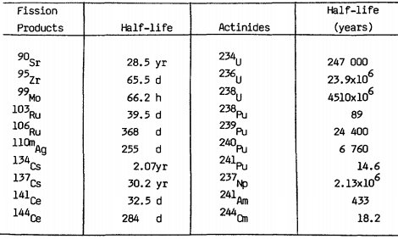

2. Activation Products
Contaminants can be formed through the neutron activation of materials dissolved or suspended in the primary coolant of the reactor. The additives used for the chemical control of the coolant in LWR (B and Li) are not an important source of contamination (they give rise mainly to tritium under neutron activation). However, any impurities, which enter the coolant flow with these additives or with the make-up water, can contribute to the overall contamination. Other impurities can be released by the corrosion of core materials or out of core materials. These corrosion products become neutron activated in the core of the reactor.
The main activation products occurring in reactor contamination deposits are listed in Table 2 together with their origin and characteristics.

Table 2. The Main Activation Products occurring in Reactor
Contamination Deposits
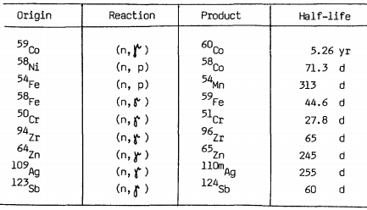

In water-cooled reactors, 20-30% of the total contamination of the primary loop comes from the in-core structural materials.
Although information about other types of reactors remains scarce, it is thought, that in sodium-cooled reactors the distribution of contamination between fission and activation products would be about the same as in water-cooled reactors. In gas-cooled reactors the contamination would essentially consist of fission products and the levels would be rather low.

DECONTAMINATION PROCESSES
Decontamination is defined as the removal of contamination from surfaces of facilities or equipment by washing, heating, chemical or electrochemical action, mechanical cleaning, or other techniques. In decommissioning programmes, the objectives of decontamination are:
- to reduce radiation exposure;
- to salvage equipment and materials;
- to reduce the volume of equipment and materials requiring storage and disposal in licensed disposal facilities;
- to restore the site and facility, or parts thereof, to an unconditional-use condition;
- to remove loose radioactive contaminants and fix the remaining contamination in place in preparation for protective storage or permanent disposal work activities;
- to reduce the magnitude of the residual radioactive source in a protective storage mode for public health and safety reasons, to reduce the protective storage period or to minimise long-term monitoring and surveillance requirements.

General
Successful radioactive decontamination of surfaces will remove all films and contamination, without excessive corrosion of the substrate. It is a clean-up process in which too strong an attack involving redeposition of loosed substances, must be avoided. For an absolute decontamination the upper metal layers will have to be carried away because contamination may have diffused through the oxide layers and may have reached the base material.
The film with the radionuclides can be attacked in several ways: either mechanically (flooding, brushing, abrasive cleaning) or chemically (using solvents, inhibited acids, etc.). A suitable process should be chosen according to the nature of the substrate and the contamination mechanism.
The efficiency of a decontamination operation can be assessed in several ways. One usually uses the decontamination factor (DF), defined as follows:
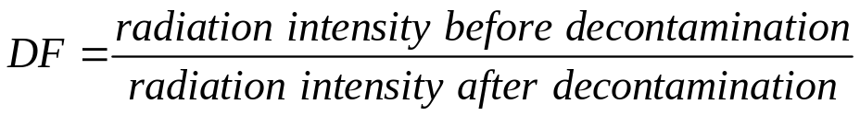
The value of the DF depends upon the specific place chosen for the measurement to be performed and the measurement technique used. The value is not necessarily the same for all radionuclides. therefore one can observe different DFs for different radionuclides. A DF reported in the literature is of value therefore only if all experimental procedures are described. It is the usual practice to give several values including extreme values and an average value.

Chemical Methods
The removal of films from metal surfaces depends on many variables among which are the temperature during contamination build-up, the age of the oxide layers and the nature of the surface. Films formed on carbon steel can usually therefore be dissolved in acids by single-step procedures; but layers grown on stainless-steel in PWRs are removed more easily by multiple-steps procedures.

1. Chemical Baths
This technique is mainly used on smaller items in centralized decontamination plants. The part to be decontaminated is immersed in a bath containing chemical reagents like citric acid, phosphoric acid, nitric acid, oxidizing or reducing chemicals, paint strippers or complex detergents.
Typical decontamination solutions include commercial cleaners, caustic permanganate, oxalic acid or phosphate base products, laundry detergents, and chloride base cleaners.
Such baths are often operated at elevated temperatures and the material to be decontaminated is moved in the liquid to improve the washing action. It must be remembered that once an immersion bath has been used, its contents are contaminated, so, care must be taken not to contaminate grossly the solution early in its life, otherwise it will not be suitable later for slightly contaminated articles. Furthermore, considerations should be given to the fact that this solution will eventually have to be treated as liquid radioactive waste, and that existing liquid waste treatment facilities should be capable of conditioning these wastes without problems. Finally, it should be noted that equipment which is not discarded as waste may need careful decontamination.

2. Equipment Rinsing
This method can also be used for contaminated chemical process loops or components of circuits carrying radioactive solutions. Loops and components are filled with the agent which is circulated until the required decontamination level is reached. Replacement and/or make of solutions is needed to avoid recontamination, thus close analytical follow-up is imperative.
On equipment with large vertical surfaces, the chemicals can be applied as a gel that, after a certain time, is removed and the surface cleaned by rinsing or spraying.

3. Chemical Reagents

3.1 Inhibited acids
The most effective decontaminants on carbon steel include 8-10% solutions of sodium hydrogen sulphate, orthophosphoric acid, sulfamic acid (NH₂SO₃H), citric acid or diammonia hydrogen citrate, and oxalic acid. Typically these solutions are used at 90°C with a contact time of 1 h. Caution must be exercised with H₃PO₄, citric acid and oxalic acid which form insoluble compounds with iron, to prevent redeposition.
Since the corrosion of metals in acid solutions occurs an inhibitor has to be added in an adequate concentration. The inhibitor has to block the dissolution of the bare metal but must not affect the reaction rate of the oxides. It has to be soluble and chemically stable at the operating temperature and the possible decomposition of reaction products must be harmless.
Of course, corrosion catalysts such as Cl– and especially F– are excluded. The most useful inhibitors are complex organic compounds which, when placed in an acidic medium, form ammonium, oxonium or sulfonium ions. A particularly efficient inhibitor appears to be phenylthiourea.
Electrochemical protection, either cathodic or anodic, is of little use in such complex systems as reactor loops.

3.2. Chelatants
Ethylenediaminetetracetic acid (EDTA) forms strong complexes with most metallic ions (it is a hexadentate ligand through the N atoms and the carboxyl groups). Thus, it can help to dissolve iron and other such metals from their oxides and to keep them in solution even at alkaline pH or in presence of anions which form insoluble salts with them.
EDTA and its complexes are stable up to 300°C. The acid and its sodium salts are used in many decontaminating mixtures. The user has however to bear in mind, that EDTA will tend to impair the insolubilization of the produced radwaste.

4. Multiple-step processes
Since single-step decontaminants are ineffective for removing adherent films from stainless steel, more complex procedures, including a preconditioning step, are required.
This preconditioning step is done by using an alkaline solution of potassium permanganate (AP) which oxidizes the chromium in the protective oxide layer, making the film more porous and more easily attackable by the subsequent acid step.
- Care has to be taken with respect to the following. That the AP solution does not corrode either the carbon or stainless steel, but is aggressive to Stellite and other cobalt alloys. Soluble cobalt ions can so be made available for activation in subsequent operation, generating ⁶⁰Co. Aluminium is attacked by alkaline solutions, too.
- Rinsing and neutralization between the alkaline and the acid step must be done very carefully since alkaline solutions entrapped in crevices can lead to the caustic embrittlement of the steel.
The most commonly used two-step processes for the chemical decontamination of reactors are given in Table 3.

Table 3 Two-step Processes for the Chemical Decontamination of Reactors
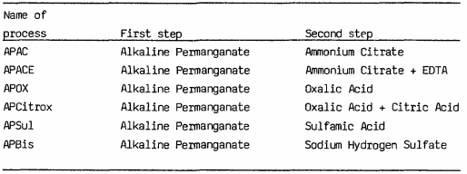

5. Soft processes
The so-called "soft" processes include:
- The use of a modified Citrox process with low concentrations and continuous recycling through filters and ion exchangers (CAN-DECON process)
- The addition of H₂O₂ just before shutdown of a PWR, or cycling the operating conditions.

6. Detergents and other additives
Greasy or oily contaminated deposits can be removed either by organic solvents (chlorinated hydrocarbons are to be avoided since remaining traces can release chloride ions in subsequent aqueous steps, thus enhancing corrosion rates) or by detergent-containing water, possibly with complexants or other chemicals.
Loose crud can be removed by water-containing surfactants. Redeposition of insoluble particulates can be prevented by increasing the viscosity of the solution by using methylcellulose or similar products.

Mechanical Methods
Mechanical methods can be subdivided into non-destructive and destructive cleaning. Destructive cleaning of surfaces is generally very efficient in removing contaminants together with surface layers of the base material and is mainly applied in cases where disposal of waste is the objective. The question as to whether a technique is non-destructive or not is not only dependent on the technique used but widely depends on the item being cleaned and its future destination.

1. Manual Cleaning
This method using brushes and swabs with water and/or detergents or cleaning solvents is based upon the cleaning techniques used in the household. It applies mainly to complicated items of small to medium size.

2. Abrasive Blasting
Abrasive blasting is the treatment of a high velocity stream of abrasive material to a surface to remove the adhering films. The abrasive can be propelled either by:
- compressed air
- centrifugal force
- high pressure water or steam.
Abrasive blasting is suitable for the cleaning of large surfaces such as walls and floors, or the outside of tanks and other process equipment. It cannot be used where strong geometrical tolerances or surface smoothness are to be kept. It is very efficient for porous materials which can be decontaminated only by the mechanical removal of the surface. Ventilation problems can occur if contaminated particles are made airborne.
Abrasives used for decontamination are sand, metallic pellets, glass beads and hard synthetic powders such as carborundum, alumina, boron oxide or carbide, etc.
In dry blasting sand and compressed air are normally used. Mesh size has to be chosen in such a way as to achieve a compromise between cleaning speed and damage to the treated material, both of which increase with particle size. Airborne dust has to be carefully controlled; this is best achieved by using the so-called "vacuum blasting" technique, in which the nozzle is surrounded by a concentric cone connected to a vacuum pump.
Metallic abrasives, and also metal oxides, are less friable than sand and produce less dust. They are usually recycled. Equipment using centrifugal force can be used with such powders.
Wet blasting results in less damage to the equipment than dry blasting, but produces radwaste water and abrasive particles which adhere to the walls due to their wetness and have to be removed by brushing.
Much of the work with abrasives is done by direct contact and therefore is limited at low radiation levels. However, there is little experience with remote abrasive cleaning.

3. Machining, Grinding, Chipping
These methods are definitely destructive methods as material is removed from the surface (i.e. a few μm up to a few millimetres).
The methods are typical for big components. The decontamination can be done either in a radioactive workshop or anywhere else in the installation. Even large equipment can be cleaned by this technique as demonstrated by the following examples:
- Removing superficial layers of the contaminated surface of a reactor vessel stud by machining;
- Grinding of the contaminated inside surface of a heavy piece of equipment (i.e. pump casing or piping).
It is obvious that these techniques can be directly applied only for equipment with contamination of low dose level. For higher dose level, long range application or complete remote operation has to be adopted.
Removal of surface contamination from walls, floors, ceilings, etc. may be an efficient means of reducing the volume of solid wastes. In this case, chipping, pneumatic hammering and scrubbing to a depth sufficient enough to remove the contamination can be applied. A powerful vacuum cleaning system is advised to collect the removed surface layers.
Special precautions must be taken where grinding is used not to contaminate other equipment and to collect all fines produced.

4. Jet Cleaning
Jet cleaning uses the decontaminating-solutions ranging from soapy water to acidic solutions, but it adds vigorous mechanical action to the chemical attack. Often water alone can be used. Nozzles can be operated remotely and rotated in all directions, making it possible to clean large surfaces without requiring the operator with brushes and mops to come in close contact with the object. Of course, waste water is produced and has to be contained, but the volumes are small and, in the case of the interior of large vessels, certainly less than with the pure chemical methods for which the tank would have to be completely filled.
High pressure is necessary for efficient jet cleaning with low solution volumes. This can be provided through steam jet pumps (ejectors or injectors) or positive displacement pumps. Pressures up to 1000 kg/cm² are used.
Most of our present experience is with the use of steam ejectors. High pressure water jetting has proved to be a very efficient decontamination technique, both as far as removal of radioactive contamination and time needed are concerned.

5. Vacuum Techniques
Vacuum cleaning techniques are widely used in removing loose contaminations. Small model vacuum cleaners can be used, inside glove-boxes in order to remove dust and solid waste produced as a result of decontamination carried out before any dismantling of the box begins.
During grinding and pneumatic hammering of concrete surfaces or in similar type operations where particulate matter is being removed from the surface, a "vacuum heat" can be fitted to the tools or close to the area of operation to remove any contaminated fines as they are produced, thus preventing the spread of contamination.
Very powerful, commercial size household and industrial vacuum cleaner models can be used. A disposal drum can be positioned in the vacuum system between the actual machine and the end of the vacuum hosepipe so that any radioactive matter is deposited in the drum and does not enter the vacuum machine. Any exhaust gases can be discharged from the drum through a HEPA filter. The drum containing the removed fines can then be used as disposal container after appropriate conditioning of its content.

Advanced Methods

1. Ultrasonic Cleaning
Ultrasonic cleaning is based upon cavitation, i.e. the formation of vapor bubbles, in the antinodal lines of a pressure wave pattern travelling across a decontaminating bath, sometimes containing chemical additives, in which the objects to decontaminate are suspended. Cavitation provides very vigorous mechanical agitation when the antinodal lines cross the surface to be cleaned, since viscosity forces are locally destroyed by the rising bubbles.
The vibrations can be induced by piezoelectric crystals (such as BaTiO₃,) or by magnetostrictive resonators. Frequencies in the range 18-50 kHz, usually in the neighbourhood of 20 kHz, are chosen. Other important parameters are vibration intensity, external pressure, vapor pressure, surface tension and viscosity. The last three are temperature dependent. For a given frequency, cavitation occurs only above a minimum vibration intensity which is related to all the other physical parameters.
Ultrasonic equipment has to be carefully designed and correctly used. The chemical decontamination process chosen has to be suitable for the job in question. The temperature has to be high enough to obtain a good chemical effect, but low enough to keep the transducers in working condition.

2. Electropolishing
Electropolishing is an electrochemical cleaning process in which the metallic object being decontaminated, is made anodic in a cell containing concentrated orthophosphoric acid as the electrolyte.
The anodic oxidation occurs more slowly in crevices and more quickly at peaks, resulting in a polishing effect which does not severely damage the surface. This process has been used at Hanford to decontaminate pieces of equipment and make it possible to recycle or dispose of their waste with less than 10 nCi/g of alpha-emitting radionuclides.
A limitation on the process is that the pieces must be small enough to be soaked in the cell.

3. Laser
This process, still in the development stage, aims at removing thermally the upper layers of contaminated metal or concrete surfaces. The energy would come from a coherent infrared beam. The vaporized material would be caught by an appropriate ventilation.
Laser decontamination would allow easy remote operation and is essentially developed for the treatment of surfaces in a high radiation environment, such as the reactor containment building.
However, a lot of work, including an economic evaluation, remains to be done in this field.

4. Other Techniques
Further techniques under development or proposed for investigation are:
- Flame spalling – which is used in steel factories to remove oxide layers from steel plates and large bore tubes.
- Plasma-cutting – is already often used for the volume reduction of equipment, even under water. It can also be applied to remove sticky surface layers by heat shocks.
- Spark machining – a technique used for the manufacturing of precision tools by attacking the surface of an object with high voltage sparks.

Decontamination of Pressurized Water Reactors
The high-pressure – high-temperature operation of the primary loop of pressurized-water reactors, with slightly alkaline and reducing coolant, cause the formation of thin protective films which strongly adhere to the metallic walls. These films are crystalline, with a spinel-like structure, and consist essentially of magnetite on carbon steel and of nickelferrite on stainless-steel and high nickel alloys. Chromium, although present in minute amounts, strongly reduces the solubility of these compounds. These films incorporate or adsorb radioactive activation and fission products, which then diffuse through the oxide layer and in some cases can reach the first metal layer.
Mechanical cleaning methods are effective for removing loose or weakly adhering crud, but cannot strip away the tightly bound protective layers.
Single-step chemical cleaning using inhibited acids can remove magnetite on carbon steel but is unable to dissolve the chromium-containing passivated layers on other alloys.
So all practical methods for decontaminating stainless steel portions of PWR primary loops will include a pretreatment step with alkaline permanganate (AP) which oxidizes chromium to the Cr6+ level, making the film readily soluble in acids.
Use of oxalic acid in the dissolution step is questionable because heavy redeposition by precipitation of ferrous oxalate occurs after a few hours of contact. Ammonium citrate and phosphoric acid present the same drawback but to a lesser extent. It can be minimized through use of iron sequestrants such as EDTA.
Present experience in decontamination of PWRs (including pressure tube, light-water-cooled, graphite-moderated reactors such as Hanford N) is summarized in the following table and comments, (see Table 4).

Table 4 Examples of PWR Decontaminâtion
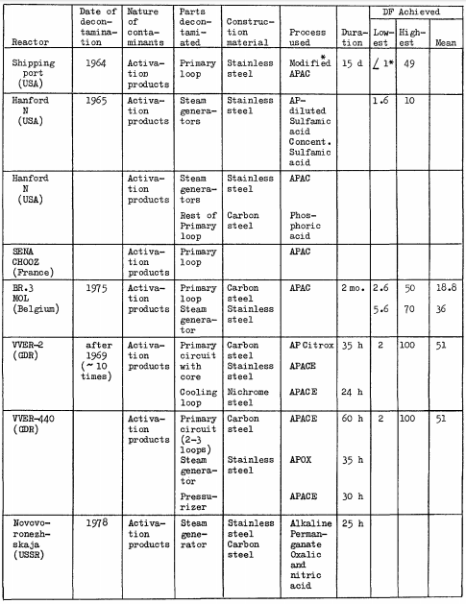

In addition to the so-called "hard" techniques discussed so far, there are "soft" techniques involving one of the following:
- Addition of H₂O₂ to the primary coolant just before the shutdown for refuelling. This increases cobalt solubility. The cobalt-charged coolant is treated by the normal chemical control system.
- Temperature, pressure or Redox potential cycling of the coolant, so as to loosen wall deposits. The suspended crud is removed by the filters in the normal chemical control system.
- Addition of chemicals in low concentration to the continuously recirculated coolant. This technique will be described more thoroughly when studying HWR decontamination. The operation at the port of shipment (see Table 4) was a step in that direction.
The "soft" techniques would avoid drawbacks such as:
- Production of large volumes of medium-level liquid wastes
- Handling of corrosive liquids
- Necessity of defuelling before decontamination
- Necessity of isolating corrosion components sensitive to corrosion by protective coatings, flushing pump seals and glands with deionized water or treating only part of the circuit.

DECONTAMINATION QF EQUIPMENT, BUILDINGS
"Equipment" means any part of a nuclear facility except for reactors and small laboratory facilities. It includes pumps, valves, nozzles, pilot loop components, remote handling devices and large vessels, tanks and contact devices used in reprocessing plants, waste management complexes and other fuel cycle facilities. Pieces of equipment usually can be removed from the place where they operate and brought to a specialized decontamination centre.
"Buildings" include laboratories, hot cells, reactor halls and other rooms used for activities involving radioactive materials. The walls and floors of these constructions can become contaminated, either inside or outside, due to normal plant operation or incidental releases.
Decontamination decisions in these fields involve safety and economic considerations. The decision-maker always has to keep in mind that various decontamination levels, including no treatment at all, are possible, and he must reason with the future destination of the item to be decontaminated in mind: its reuse in a nuclear facility, release as waste in a controlled repository, or in an unrestricted dump, entombment of buildings including some physical protection, their demolition or release for unrestricted use; ground to be used as an industrial estate, as a residential estate, as agricultural fields, buildings to be condemned, and so on.

Selection of decontamination technologies for decommissioning
Very early in the process of selecting decontamination technologies for decommissioning, it is important that a cost/benefit analysis be performed to see if it is actually worth decontaminating the component or facility, or to determine whether a mild decontamination at low cost is more advantageous than an aggressive decontamination at a higher cost. This analysis is usually accompanied by extensive experimental work on selected samples from the facility in view of characterisation before the final choice of a decontamination technique is made.
To achieve a good decontamination factor (DF), a decontamination process must be designed for site-specific application taking into account a wide variety of parameters, some of which are listed below:
- type of plant and plant process: reactor type, reprocessing plant, etc.;
- operating history of the plant;
- type of material: steel, zircaloy, concrete, etc.;
- type of surface: rough, porous, coated, etc.;
- type of contaminant: oxide, crud, sludge, loose, etc.;
- composition of the contaminant (i.e., activation products, fission products, actinides, etc.), and the specific radionuclides involved;
- ease of access to areas/plant to be decontaminated, external or internal surfaces to be cleaned;
- regulatory requirements and decontamination factor required;
- destination of the components being decontaminated: disposal, reuse, etc.;
- time required for application;
- proven efficiency of the process for the type of contamination in the facility;
- type of component: pipe, tank, etc.
Other factors which are important in selecting the method, but which do not affect the decontamination factor are:
- availability, cost and complexity of the decontamination equipment and consumables;
- need and capability of treatment and conditioning of the secondary waste generated;
- potential exposure to hazardous materials and/or chemicals used in the decontamination process;
- occupational and public doses resulting from decontamination (justification of the practice);
- other safety, environmental and social issues;
- availability of trained staff;
- extent to which the plant needs to be decontaminated to achieve acceptable conditions for decommissioning;
- salvage value of materials which would otherwise be disposed of;
- extent to which the facility must be modified to do the decontamination: isolate systems, enclosed and ventilated spaces, etc.
In addition, the choice of a process or of a combination of several processes will finally depend on several other factors such as:
- the specific nature of the application, the complexity of the system;
- the feasibility of industrialization;
- the cost/benefit analysis taking into account all aspects of the decontamination operation, i.e., until disposal of remaining radioactive waste.
The decision whether to proceed with decontamination and the final process selected will depend on the best overall balance of the above factors in order to minimize the overall impact of the decommissioning activities on workers, the public and the environment at acceptable costs.

